**CONNECTIONS**

**Dear Residents, Family, and Friends:**

**As we bid farewell to another wonderful year, lets take a moment to reflect on all we’ve accomplished. To our incredible residents, families, and staff – thank you for making 2024 so memorable. Each of you have contributed to the warmth and joy that makes Lanark Lodge so special.**

**The New Year is time to look forward with hope and excitement. We are ready to build on the foundation we have created together, continuing to grow as a community and striving to make each day even more fulfilling and meaningful for everyone. Whether through activities, stronger relationships, or simply enjoying the moments that bring us joy, I am confident this year will be filled with much success and happiness. From all of us at Lanark Lodge, I wish you and your loved ones a Happy New Year filled with health, joy and prosperity.**

**Shawna Stone**

**Director, Long Term Care**

**\*~*~*~*~*~*~*~*~*~*~*~*~*~*~*~*~*~*~*~*~*~*~*~*~\***

**Welcome our New Food Services Manager, Haley Waldeck**

**After nine years at Lanark Lodge as the Food Services Manager, Cindy McCall has retired.  We wish her well in retirement and her future endeavours.**

**Taking on the role of Food Services Manager is Haley Waldeck. Haley has been a committed member of the home since 2001. She brings a wealth of knowledge to the department with her background in customer service and advocating for residents’ choice. The dietary department remains passionate about providing our residents with meals that are delicious, nutritious and of highest quality**

**Taste Like Home Recipe of the Month Program:**

**Residents are encouraged to share and enjoy their favorite homemade recipes. Each month a recipe will be chosen, and the selected resident will receive a tour of our kitchen. Recipe options can include baked goods, snacks, main dishes or side dishes. The options are endless! For more information on the program or to submit your recipe, please email** [**hwaldeck@lanarkcounty.ca**](mailto:hwaldeck@lanarkcounty.ca)

**HOLIDAY CHEER!**

It was a fun and festive holiday season! We ran programs like 12 Days of Christmas, Shop with a Cop, Photos with Santa, enjoyed lots of Christmas music, and had Christmas and New Years Eve parties. From our staff and residents, we wish you a healthy and happy 2025!

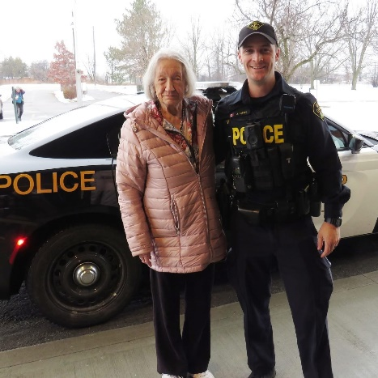

|  |  |
| --- | --- |
| **FASHION SHOW!**  Lanark Lodge residents and staff participated in a fashion show.  The event began with hair and makeup and ended with lots of laughter and smiles on the runway. A huge shout out to all who participated as well as those who donated clothing. |  |
|  |  |
|  |  |
|  |  |